South Asian Health Support Programme
Annual Report 2007

Background

Ethnic minorities coming from every part of the world contribute to 5%of Hong Kong’s population. Although ethnic minority Hong Kong residents have the right to live and work in Hong Kong, many of those particularly from South Asian origin face struggles in doing so. Barriers of language and culture restrict their ability to integrate with Hong Kong society and limit the opportunities available to them. Even access to basic services such as health care can be a challenge. Many of them are prone to be ignorant about the health information and services available for them. In most of the cases this is related to language barrier, access to health information and service, socio-economic status and their level of support.

As a high-risk group due to socioeconomic status and lifestyle, among the majority of this community though the incidence of chronic and other disease are not so prevalent yet but susceptible to. There is a paucity of data on health status of this community in Hong Kong.

Hence in 2007 UCNCHS started south Asian Health support programme to fill in the gap in the area of Health.

Our Mission is to improve family and child health of ethnic minority groups through maternal education and training of lay health advocate volunteers.

Our service is focused on educating the caregiver/women of the family and aim to tackle problem on:
- Child behaviour problem and parenting difficulties
- Breast feeding and infant care
- Oral health
- Women’s health, Post natal Depression and maternal mental health
- Lifestyle-healthy eating and physical activity, obesity, smoking and alcohol abuse
- Prevention of injury
- Prevention of chronic diseases particularly hypertension and diabetes
- Prevention of infectious diseases

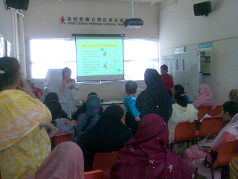
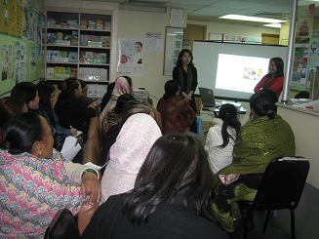
Health talk Health talk by a dietician

Significance:
- Many overseas researches have shown the importance of health promotion among the minority as they are prone to be lagging behind in uptake of many preventative health care measures and susceptible to chronic disease.
- There are also evidence that health promotion programme lodged for the local community usually do not reach the vulnerable community such as ethnic minority community. Our programme has filled in that gap.
- Prior to attending our health training many of the women had little knowledge about prevention of chronic disease and association of chronic disease with lifestyle.
- Many housewives and low educated women from South Asian origin face challenges in Hong Kong. Many of them do not seek medical help on timely manner because of lack of information or due to language and cultural barriers.
- Others rely on their peers, isolated from the health service available for them. With the native speaker staffs from the South Asian community we hope to break that barrier.
- Many of them have lived in Hong Kong for years and often feel hopeless and frustrated and even tend to go back to their country to seek medical help. Our health training offers them an opportunity to learn something new but very essential, build up confidence regarding health seeking behaviour, build up relationships with others and empower them to live healthy life thus build up a healthy community.
- Significant number of women who attended the health training programme is trying or started to consume less fatty food and more fruits and vegetables.
- The need for our services is evident from the statistics. In 2007 within 6 months our training was attended by about 150 women and our health talks were attended 680 times.
- Over 205 women got Pap smear test.
- 404 South Asian women and children received flu shots, before and during the peak flu season
- Mini health check i.e. Blood Pressure, Blood Sugar, Cholesterol and Body Fat was measured 1260 times

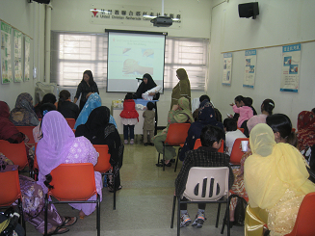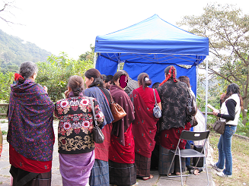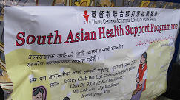

Women lining up for health check Health class run by a trained volunteer

Facts and figures:

Beneficiaries

Mini Health Check

Health index | Women attended  N | Women with  BP>140/90  BS>11  BF>27% | % of women who had abnormal findings
Blood pressure | 528 | 199 | 38%
Blood sugar (Random) | 340 | 23 | 7%
Body fat | 239 | 230 | 96%

The result from the body fat and blood pressure was significant and indication about their vulnerability to long term morbidity. Following the result intensive health information was given about chronic diseases and healthy lifestyle. Rewards were set to those who follow the healthy lifestyle. To our amaze women did follow our instruction and there was significant results. For many of the women it was the first time they had opportunity to measure blood pressure and blood sugar. Despite of the abnormal finding some of them were glad that they found out in early stage and started to follow advice regarding healthy lifestyle. Consequently one of the women lost 12% of body fat in 8 weeks. This result has also given us a clear indication that there is lot more to do for this community.

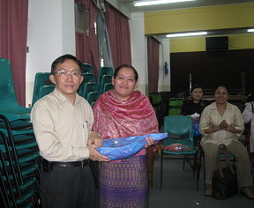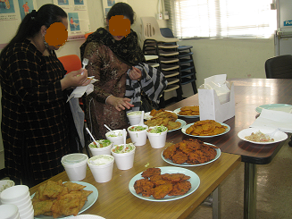
Winner of the healthy lifestyle model South Asian food sharing
reduced 12% body fat in 8 weeks

Result of the survey questionnaire
Demographic Characteristic (included only those women who had completed 75% of the training course):
Characteristic | Frequency n=150 | %
Nationality  Indian  Nepalese  Pakistani  Other | 5  60  82  2 | 4  40  55  1
Age group  20-30  31-40  41-50  51-60  >60 | 58  37  25  13  16 | 39  25  17  9  11
Education level  No schooling  Primary or below  Secondary  College  University | 26  63  40  14  6 | 17  42  27  9  4
Marital status  Single  Married  Divorced/Separated or widowed | 17  128  4 | 11  86  3
No of children  0  1-2  3-5  >5 | 18  52  62  9 | 12  35  42  6

Pre and Post KAP survey indicators
Variables | PRE KAP |  | POST KAP |  | Difference
Variables | N=150 |  | N= 150
Variables | Frequency | Valid percent | Frequency | Valid Percent | %
Had Pap smear in last 12 months  Yes  No  Unsure | 10  99  35 | 7  66  24 | 49  82  14 | 33  55  9 | 26  11  15
Daily sports  Yes  No | 86  55 | 37  58 | 103  41 | 69  27 | 32  31
Daily Walking Habit  <15 min  15-29 min  30-44 min  >45min | 32  56  27  25 | 21  38  18  17 | 9  48  52  32 | 6  32  34  21 | 15  6  16  4
Household consumption of vegetables  None  1-2  3-4  5 | 1  62  70  12 | 1  42  47  8 | 1  88  46  4 | 1  58  30  3 | 0  16  17  5
Household consumption of fresh fruits per day  None  1  2  3  4 | 12  65  55  11  2 | 8  43  37  7  1 | 9  54  66  12  2 | 6  36  44  8  1 | 2  7  7  1  1
Statistic analysed using SPSS 16

We observed significant difference in uptake of Pap test, daily exercise habit and consumption of vegetables. However due to small sample size and quality of the surveyor we believe that it is likely that the result may not be as standard but it has definitely identified the need and the intervention worked.

Pap smear finding:
Total no of Pap smear  done (Feb –March) | No. of First time Pap smears | Abnormal PAP smears (all abnormalities) | Epithelial Cell Abnormality | Most common Age group with abnormal finding
205 | 166(81%) | 24(12%) | 7(3.4%) | 30-35

The abnormal Pap smear rate of 12 % (all abnormality) is high compared to the rate of the general HK female population as described in the Department of Health Cervical Cancer Screening programme of around 8% (all abnormalities) during the same period i.e. the first quarter of 2008. Early detection of abnormality allows early treatment and prevention of cancer.

Funding
Our programme is funded by community chest. Securing funding for several years is essential to sustain the project and make a long-term health promotion impact in the community.

Staff
Our staffs from the South Asian origin with health professional background offer health promotion service for the needy in their native languages.

Way Ahead:
Supporting vulnerable ethnic minorities is considered to be complex issue because this group has different needs to the general population and can require considerable support to enable them to deal with health issues. As our project is still in initial phase we will require additional resources and need to change in ways of working and thinking.
We look forward in 2008 and beyond to further strengthening our health support for South Asian ethnic minority community.

We will be starting home visit programme this year to reach those who could not afford to attend our health training due to various reasons. We will also be putting health information in the website in several South Asian languages.

We believe it will give us true reflection in preparing further appropriate health promotion interventions, which may even make us modify existing services or develop new ones.

Our contact:
United Christian Nethersole Community Health Service
South Asian Health Support Programme
Jockey Club Wo Lok Community Health Centre
Unit 26-33, Basement, G/F, Kui On House
Wo Lok Estate, Hip Wo Street
Kwun Tong, Kowloon
Tel: 2344 3019, Fax:2357 5332
Website: www.ucn.org.hk

